("frltriitG q,)
ffi :*s
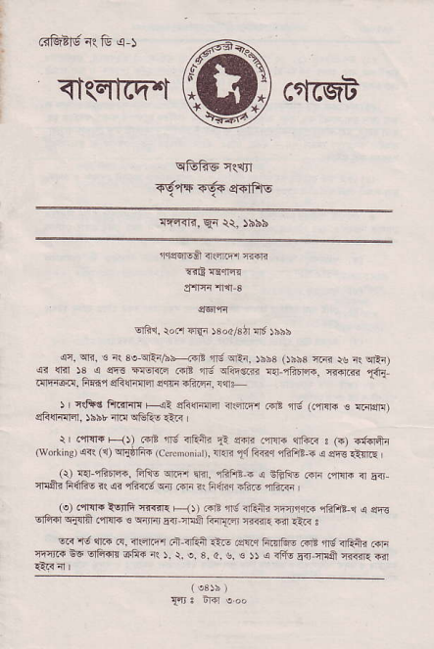
<I(qfcq''"t crrcsiF
^{q&iiF} {irtrT
{q.lF €€{ sTiPlE
^{:r4.Frrn,} E4 tt, )bbi,
_{fisqlEa} ^{q€r6r} ffi
T.d ef?F
:Flr:n'n{i 3
^{Elfii.} rocr FEr $ ocl8b cld )bbb
_{cc.} ^{qri,} € _{i\ 3!} ^{qiiar-?rr} _{r'6} ^{qft. rbb3} _{ob53} ^{{.i!} rs _{aq} qRr) _{r{ri{fi!. E]?ltri} ^{q]nllr{qT} sc||| 6t@ r{ts
_{- ) r} ^{qft8} Fl.jlill +? sFqiflql ?sqr.r-'r _{.rE} ^{ing} (nFra € {61$,F) _{sFlrfi4. ibir 4.r} ^{qGfrE} r!:ir
I .iftn FIJ) .,irB ^{'lfd qQ+i} _{R} s|.ri .,i!rs ^{lrrtu<} s (.) iffir (wskiio.qr|( _{cEhft{ (ccrnonjrr),lrr?} ^{,j{} _{F,nq} ^{ql?fi?-- j} erg tflrE l (r) € rhiR. _{Ffts} ^{qlr} _{w{.} ^{qffiB. q nftis} .dli irlm. _{nRS! F{fiE (} ^{q} _{rFRrn} ^{qd} r+li i( fr6?q ili.E 4ft.€
(e) dirll.lqli ^{{.{iR F} _{ft FE} ^{5lrs4fttu lqiJrqi.} _{"lfiFr-.r} .! s13 _{!rFi{} ^{qs1?} _{."mi. s Erra} ^{gir} 'I{S f{r{i:i ^{rFjL .ir} ali-{ s B rV $.r G. irrElie1 .i-dii .tE .@.| FftfiftE .irB nd din? ffi *l]R Sq riFr$n sfi{ rs )- r, _{e, s, d,} ^{g.} ts )r a ^{rffE} _{Fir} ^{qEA} Tfiir. {rl
(
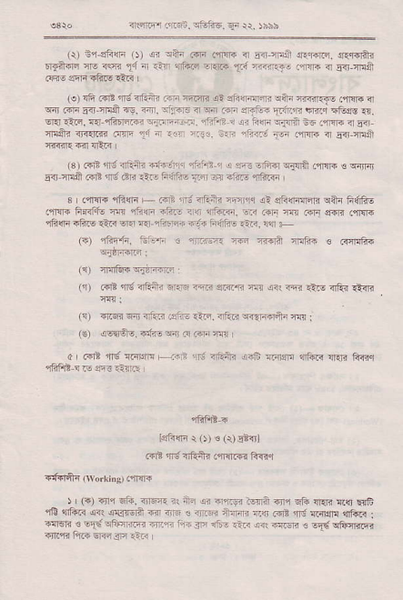
_{{r)} ^{i13fr{F*} _{O)} {i oinr ffi .'rii. ^{ir} _{Eir} Eel ar{irF. n1fnifi ^{EllftilE ft ffi} _{1"1} a .14 ^{{FFs cEn4} _{t';:F<.J- .4n]i} ^{q} 5.{ lll8
(!) !fi rE rS 4Eii r ?qnF _{!a !h!r{r1sri} ^{qatn q...?€} firG ir ^{qir} ffi rir 41ii @. flr. trilFE <rF _{i.5} ^{sritre?} _{ZiE} r.6rfl"' {G!" {. ^{Etq} rrtn. ^{aar-ifirFFi} _{"rr-} ,'n!,rj. r"rl:, :| ^{iin -liri -tr} .ffi < 6i ^{{rafti ii<{.m ff} _{1a} ^{nr} _{{.i} ^{,:J:. !'.F .li-j} _{1d} ^{..1m a} _{Elj} m-!it n-m-?r {ER
(3).€E,|J;ifrih @A{1r rFFil 1 i @ _{-f4{} ^{qj} ril .qllri _{e} qirB _{E-ir-nrlS @d} ^{,N} .tr _{{-!} ^{'ldfls} _{{.ii} ^{tr E?F} "rftF
_{3 .'lrrf. 4jiqr" + ra, {t aain} ^{'m'n} rl _{sji4{{l<r?} ^{qltn} fi(liE i'tr!]. _{FsiJio fr} ^{qi4{r'1} _{"F." rrn} ^{qrfffi.} w @i m 6ri $€F .fir{
^{rfin .hr} _{{aF} w lrr-rl4'.4 ^{ir'{i} tuifF iaF. i{ -
r TFd trf€ a crrft.
.ot {g'aFiE _{:rlE} ^{-ff} @.. € a<r @ l11r .r1ii <ik
r'f6 fl d.i i!i- iils. _{4Fir} ^{qr?redi3} w l
_{ae.r€i€. r'€s} ^{q} F rlim I
a _{.rrd} ^{,ld} _{".iFl]!} --,.; ^{.i-} <iinii dnfr _{rtr€r} ^{q6.? q.ri} fa4q
1fiFd-i
^{leftn r} _{o)} ! ^{(r)} E 5l
@R r! nf.i< !,n{l@ F-n.r
) ' (") _{in,i} ^{qtr,} _{cFjr il} ^{rrli} _{ar} ^{ql@} itrir 4nl _{Ein} ^{1rr5r} {{] ^{E*6} _{,ii} ^{'{ira'R qr(} $ls.r!la F TF s irci ihraf4 ns _{rr? rfS !i4rq} ^{?nfari} I -!l6fi r EI{.oFFr@ T.r inr 3tr 1i* .iF {q ^{l.ilw} € !E{ lfillm
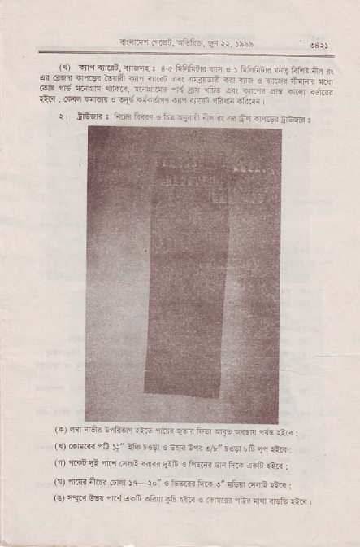
_{i5la1.'lrtln,} ^{qGft6.} Ei r\, )bbb
rr, ^{{flcqr$:.rrqE} ! B.d FJts4ln- tr € ₎ 1it6? ^{qil} !if, _{4.} F ^{r?} _{.'el} ^{qqB} .qdr.l ^{r.} _{r.in} ^{.q} .E{r? ^{a4 nG} € ?@ ti$q it4 @ ^{rrre} _{scdl{} ^{q_fc. lt;Jum} r,{.{F f'! s,
^{.rr!} : cf.r dfsB ^{s !Fr'-i?lrrfi} -lli flrii fifi TiiF
r lGrrr s fim friq € _{tu} ^{q{qlnf} na _{n<} ^{qi} &r ^{{l,ftFj} iEqr< :
^{rr,} "" ^{-e:;r* oar"} "@ q'" 1i ^{i} _{"rl;s.rl!iE-=a-n} . rq) _{@rrq} ^{?E} \" tto !6Er € r{n cr o/r" bc.El bt .1' ^{lrR} . (t ^{qran} _{!l} ^{lllFr q{rt {iRr} _{GF} € FqB Eri ft- {.F .t! | (s) {.i? ftri @rEl JFio" € 6oa{r FR ^{e"} &4r F4R r!i< : ^{(€)} c.{c{ ^{tq} _{"ilr{} ^{q46 aFfl} 16 1!in { .T'!1T. cE3 !r?n <9c €<
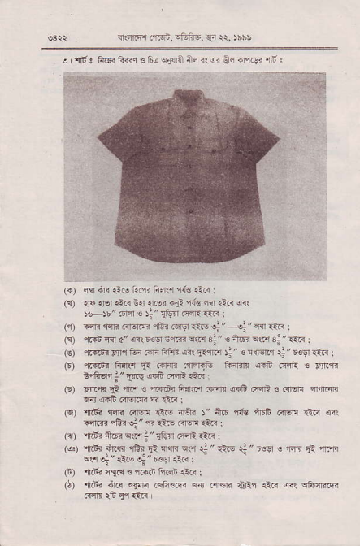
(.1 fl:n4 r.F i.,'i hn{ 4i€ rlF :
_{tlJ} ?l* rM ?1e 6{ _{r@} 6ln 1n? fl rtr< frr
JH',,@ ⁶ _{!,'IEff} F4E €R :
_{(jr)} ^{lm} liE Frcr.fr ^{iEr .Na-!r"} _{+"@r-} : (!)'rr4nqir c" _{inlbcv cffi} ^{qlH 3:" € nFa".P} _{4"€3} : (e) r@n< _{Fn,i} i' rln ^{r4Fi aa!} _{ahln} )i ^{" e 1liftr} _{ii} ^{" rcgr} _{"rr:in} :
(E) ^{r{ift 6+3} _{'i} Frn rr1ttr16 6iilr GE Fri ³ Fn n ^{s.@rr} _{l?-cg} m rm.4.
€) _{Fn} ^{G} _{F} ^{'mr} € er4.E? FrMr4m <.8 F-E € l?@ nFmi 6naFiil3rg@q€R:
⁽⁶⁾ _{ftf,r} ^{jrsR} .irw 1i- _{4Ai} ^{y'tuF} stu iFri .nm _{e?i} (ae ^{liffi} _{iir} ^{q"} r _{€i-} ^{(l@} i-F:
_{la)'r.i1nG} ^{qln;"rtuF} r4F rta :
(e) {aii ftq 1E? 5i 4q !.r _{r;} " 1ire rl " ^{'!s € ffi} 5r {."8 o{!!"1tE ^{q"reei-a} I
_{F)} ^{,mrr i{rR €} _{"fa.i} i"f.i rnr :
_{O)} ^{,mfi} iri!.e;,ra 6Fcm w 4m AFr.?'n {rl e6nl@
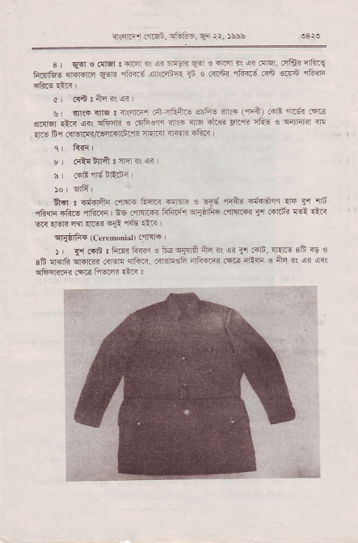
_{<ifi, r.i;n.} ^{illl:@.} _{Frir.} )ns:
_{s} ^{q€l} _{€ FFr} ^{j} ri.r ?. ^{.i Ir]m} _{.1} ! ffi it di _{rF} qFa4 qJR. _{Frif6- fnffi €-F} rlriri !i..nE.7a ^{3.a.na} _{"ia,-'} ,an n 4.F
di.{63n]i11ai
s1lrq _{1lF} ^{qni qtu"r} _{€ 4nn!,*r} ^{,i1.} 4r! _{nnc nl"} -1}. _{c !{ffi} 'E _{irF tu 1<ffitrdr.F.n} ^{:lrm} rr<lP 4,.:ri
r drt{ffit 3 ?q i: rr
_{s F* fl!} 6RrEi
A- : cird_h .'ffi EnF {r € _{-F,'} ^{'rii4} i19611 rF _{{'r} 'iE 166 _{aftF} ^{,ntuid} L e6 rffi tr"zii il1iFJe ^{.T Flr} _{f} ftritri ril .ni _{w rl5la} ^{q} {@ +df i13 inF
^{q]atrR} _{rc-dNnhrr} ('[e
J ' _{!'j} @i i tuFi _{linl.lidsjinii} ^{rl. ilai} _{fl Fr;. n F 8fi} ?u € sF {afi ^{eriB .lm} _{"ilri.} .;m!F_ iti-fr .m iln 3 nn iq ii r.r oFinF.Fr l@ hlr ?tF :
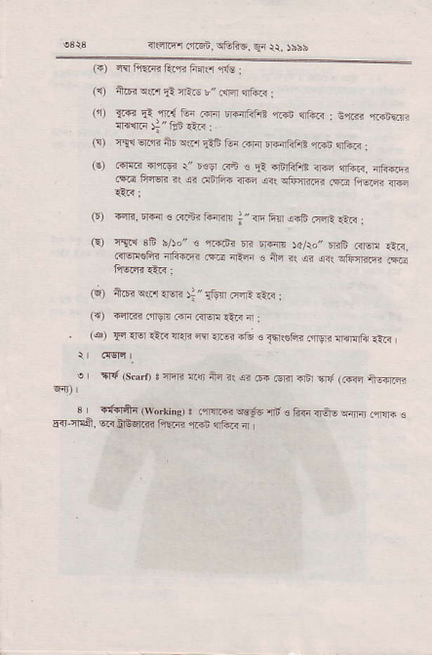
!3r3 _{nnriry.,rcf,} ^{qGfi6_} Er r\ )6bb
(+) i{I riEii? ftc ft{$ ^{1{s} i
(l i@ ^{w1} _{lt} ^{qEF} },, _{.rF} ^{qfti} :
rn 3rd i: nr{ F i _{@ lFatu} ^{..d} liti . sne {..ftc ^{{rd@} l"tti.iF.
(9 Tlc wfi _{iE} ^{qsl} rlE 6r erir lrf4rFFT! rii.i ^{qft.<} ; (€) ^{.{le rl'r.gi} r" esr ^{Gi s} !i {rirFfi? iF $ft<, irii.6 _{.!a €i{€E i!} ^{q?} dirFi _{rr@ ar\} ^{qtuqlr?q?} .@ titm r]{E
(r) {iri, ^{fiFr e @fituff4} _{;"Trfin} orF r4a €< i (F) rT.c 36 5/ro,,. i1?linr m E]€n )d/ro,,rrB .irw ^{!-.<.} r?iqroFfj rftffr (@ 4Rn _{€ nq ns} q? ^{qq} cftmifi ^{i\ii} ftiq*€r1;
6) ^{fizErql.'l{ER} _{t"$!l} ^{Fs,i€i<} i
({) .4.1r .{fsr! ini Rl€r! Etr< 4 :
^{. (q)} F _{rM llR rr{!} ^{qy} rl.€? ?d 6lqRtFi flgrn @Frri €R , e r .r{ (s.aro ! inB rilr ar 3R an @ .€rfl F6l f (F+r +6q.sn
^{s} ₋ rtr+rft' {wddons, I.-rnrq wgd.li < ft€ {fE - _, { -.rd € 5{ T!d,6@irB.n.fi ^{fqEF} "rF r]riR4
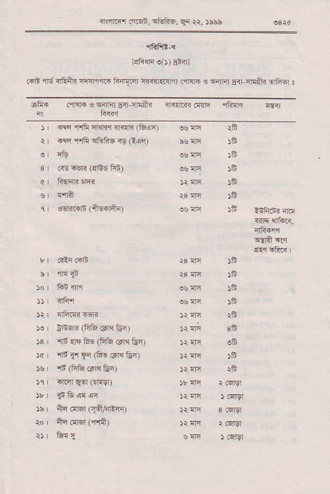
_{ar4.fl mGf.} ^{qGinF. qr} *. )bbb
^{,iFFE} C
Lsftn ao) stirl
arp nrd <ftn" m1rq." Fq.sr ffi<qn .qr{F ₆ ^{q{r{} Eir-ira+i !fii5r :
r _{{rc} ^{'f.rF rcq nrr4n} &an)
r lac _{{rF} ^{qffis} rs R(c)
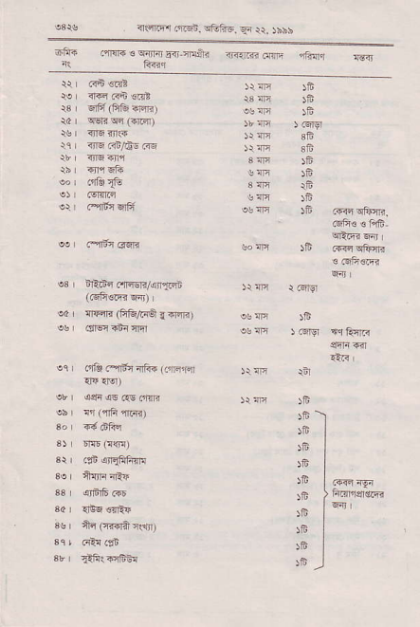
_{rFm r@i.} ^{qtu6d qr} rr, rshh
^{6Y+} _{.fe e} ^{qF} m.T!+.
i( frdq
$ | irtnq alriEi./an1&-E
^{q r nFdlt (F&/t{6} {ffi)
eq oda .3r'r 4Fi (ni'lEr
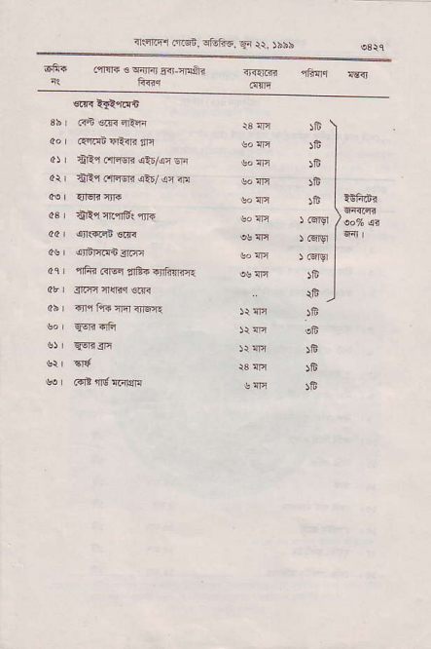
^{rlq.qr} _{rftei.} ^{qfoftc,} {i {r, }hih
cf6 _{.,M €} ^{q4rFj lFj 4riii} <t<{rni ffi{q lrn
^{'n'Fi r<Iqlr} ,lB.-rrhfiie
^{"O}rF
)E
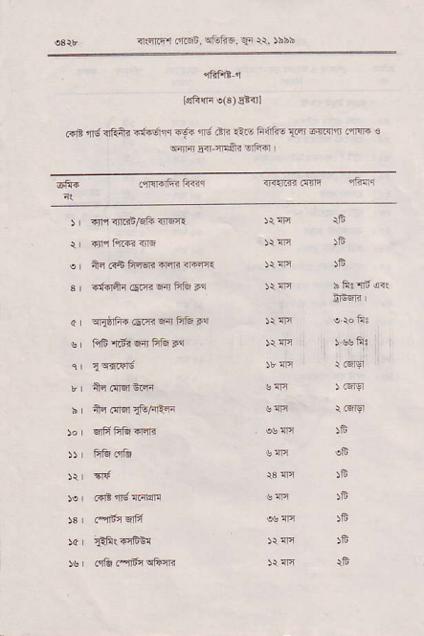
oslr _{<ltcrF! 6f6i,} qtri6, ^{qi} tt. )bbb
"ihitt-'l
_{lcli{fi} ^{e(3)} Er{l
_{.{E} ^{'rd} iftntr ituir si+ rrg dr? rlF ^{fi{ii6} _{{..r} 6{1q$ .,m ! ^{qrir} _{Fir-ql8i} €rfitl
) _{4'rl} ^{qn.rn/El-} 3r!i|1
er an rd Filsrt ffi{6441
s {ffi{ _{@.ri} ^{qir} Flfu }{
_{cr} ^{qqldi.} @r{r6li& Pq
v _{fiib'rdi} ^{q{} fr& }{
JF
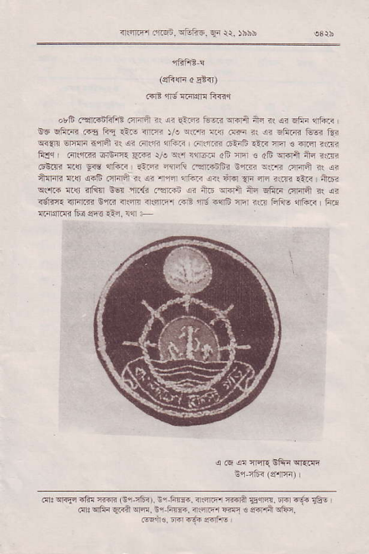
_{4.im .a4in} ^{-,Em.-n} rr siii
_{"fii1t} !
^{(Efimi o} !t{)
_{ad?} ^{'tri.'} @Etn ft<q
orlt .!r..uiFrt fiF;i ^{?! rr} _{ar.fr} tuB ^{-@l} n il si Eiii dri _{tE} ^{qir@} o€ to. _{.i1- ffi 5/!} ^{qrF} _{{4 tF ?<} ^{qr FftB GB tsi q.!n} il:M _{nlra 1} ^{q<} 6rn 4ftF .{lgrn .6i'?b ?iF _{m !} ^{qFl} ?{* _{fjq} , 4Rr,-n 6iqqr r.4n _{Vs} ler !4@ dF m € ₄₆ ^{qrd4} ftd 1r _{6QR} ^{q$} !€ 4rhF _{-.F} ^{q4Fft} _{1Yli5nF< n'i:-,r} ^{qqF} FFra * er +ndi !L!r ai6 .rr?dl _{nl} ^{qr} _{a14} ^{,f-4} _{ii,} ^{,iR} _{{4} ^{n i{r4} €F +n ^{q$r} ftlr lilr id r,{n _{.3r5} ^{q ;i6 iwn} ii- Efii/r .nFm ir e. {iEe 4FlF i'r@ irw {iffii FE rrj i{E nFr ilir ffiE fdi ' tuT :@rd? 6a @ r-n. n4 -
a @ _{{! nFr_{ E&r} qram
^{d:q?kq.€!ffi} _{G.-n64).} ^{i! 6w {rffi F@n} _{sffi.} ^{rF -.6} liE, _{n:} ^{qFa q!..4} @. Ei-F6i- _{i!.@r} ^{lw} _{! ofna} q]{n.
@!irs. tF-.6 sf,E

